

Beneficial Cargo Owner Account Criteria

Last Updated: May 26, 2022

Version 006

Table of Contents

**Revision History** 3

**Purpose** 4

1. Account Setup 4

Request Form 4

Registering for CCMShipments.com 4

2. Reporting Shipments 5

via CCM’s default template 5

Reporting Frequencies 6

Reviewing file-upload errors 7

3. Changes to Account 7

4. Street Turns 7

Guidelines 7

File Layout 7

5. Account Effective Date (go-live date) 8

6. Disputes 9

7. Contacts 9

# **Revision History**

|  |  |
| --- | --- |
| **Date** | **Change Description** |
| 10/19/2017 | Initial Version – Brittany Krieger |
| 01/02/2018 | Edit & cleanup - Brittany Krieger |
| 03/15/2018 | Edit – Brittany Krieger |
| 3/1/2019 | Edit & cleanup; chassischoice.com |
| 2/8/2021 | Edit name change |
| 5/25/2022 | Edits; added error-check section – Ian Stephenson |

# **Purpose**

The purpose of this document is to establish the setup, layout, receipt and processing rules for Beneficial Cargo owner accounts. Beneficial Cargo Owners will be expected to self-upload shipments daily, weekly or monthly via CCMShipments.com in the required format to determine the appropriate responsible party for chassis usage.

## Account Setup

### Request Form

After a Beneficial Cargo owner has received approval from the provider, the provider should contact CCM with information regarding the account by sending an email to CustomerService@ccmpool.com. CCM requires that a form is completed for each account that is being set up. See below for the information requested on the form.

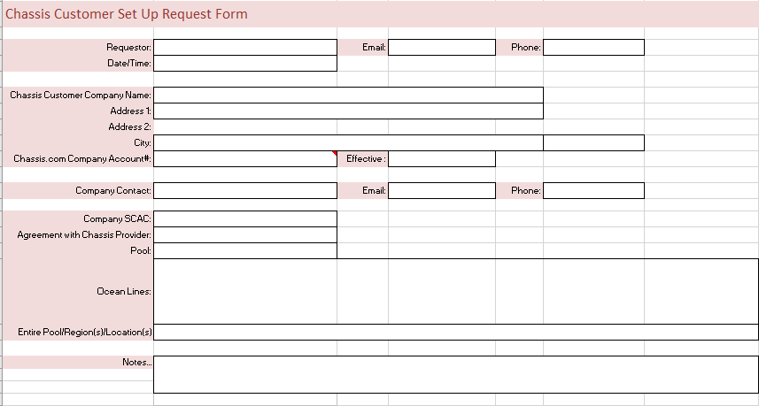

### Registering for CCMShipments.com

[Click here](https://www.ccmpool.com/Resources/Chassis-Choice-Portal.aspx) and follow the steps to register.

You will utilize CCMShipments.com portal to manage your reporting of shipments.

## Reporting Shipments

### via CCM’s default template

In order for CCM to process a file of shipments, a uniform list of key fields must be present. These key fields help CCM to identify the exact shipments in the system. Every upload **MUST** include:



|  |  |  |
| --- | --- | --- |
| Element | Required | Comments |
| Ocean Carrier SCAC | Mandatory | NMFTA SCAC |
| Provider SCAC | Mandatory | NMFTA SCAC |
| Reference # (Booking/BOL) | Mandatory | As provided to you by the ocean line |

These fields are optional:

|  |  |  |
| --- | --- | --- |
| Element | Required | Comments |
| Effective Date | Optional | mm/dd/yyyy format for ETA. If nothing is entered into this field, the date will default back 7 days from date of entry |
| Expiration Date | Optional | mm/dd/yyyy format for ETA. If nothing is entered into this field, the date will default 120 days after date of entry |
| Container # | Optional |  |
| Expected # of containers | Optional | Applies only when the container # is not known. Enter the quantity of containers expected for the Reference # (Booking/BOL) |
| Location | Optional | Enter the location code, service city or pool code. |

* [Click here](https://www.ccmpool.com/Resources/Chassis-Choice-Portal.aspx) for instructions on how to upload your shipment file using the default template.

***Using the sample file function***

*If you choose this method of reporting shipments you MUST contact CCM at* [*CustomerService@Ccmpool.com*](mailto:CustomerService@Ccmpool.com) *for assistance.*

Using the sample file function allows you to upload your own file and map the file to be converted to our default template mentioned above. Your sample file must still include the 3 mandatory fields (Ocean Carrier SCAC, Provider SCAC and Reference#). [Click here for instructions on how to set up your sample file.](https://www.ccmpool.com/Resources/Chassis-Choice-Portal.aspx)

Please note that only merchant haulage moves should be reported, where the BCO is responsible for paying the chassis charges. All door moves (carrier haulage) should be excluded from BCO/NVO files.

### Reporting Frequencies

Where possible, all shipments should be reported prior to the shipment taking place. The portal does allow a 7-day grace period for shipments that have already occurred. This grace period is determined by the loaded move.

The grace period allows any missed reported shipments to be updated to the correct provider; it is not intended to encourage late updates, but rather to avoid usage being assigned to the wrong party and incorrect bills being issued. Increasing the billing quality will also reduce effort validating invoices and needing to dispute charges due to late reporting.

It is the responsibility of the BCO to routinely update their shipments in a timely manner. If files are not uploaded within the grace period, shipments will not be updated retroactively and could result in incorrect billing.

In addition to self-uploading your shipment files on the portal, it is the BCO’s responsibility to send these same uploaded files to the provider to which they are redirecting usage.

### Reviewing file-upload errors

The uploader is responsible for ensuring that their file is pre-processed successfully by the system. This detail is obtained by selecting Shipping Management -> View Direct Shipment File. The user should enter search criteria to locate the uploaded file (e.g. date-range), then select the “Actions” button next to the file, and select “Download Errors”. The user will receive a spreadsheet of all the errors in the file they had uploaded.

## Changes to Account

When a change needs to be made to an existing account, please send all inquiries to [customerservice@ccmpool.com](mailto:customerservice@ccmpool.com). Changes to the account can include:

* Pool
* Ocean Carrier
* Provider
* Branches
* Contacts

An approval letter may be required for ocean carriers & providers contingent on their provisioning. Please visit <http://www.ccmpool.com/Membership/Chassis-Providers/Index.aspx> for more information.

## Street Turns

### Guidelines

CCM requests that, if they are known, the street turn dates for shipments should be included in a separate document (format provided below). Supplying the street turn dates will eliminate additional research and correspondence if it is provided proactively. This will also increase billing quality on shipments. No street turns will be added after a 90-day period from the start date of the shipment pair, and adjustments to invoices will not be made.

### File Layout

If the street turn date is unknown or undecided at the time the shipment is reported to us, but the customer receives notice of it after it takes place, CCM asks that the customer provide the street turns in the below format. Files can be sent in XLS or XLSX format.



|  |  |  |
| --- | --- | --- |
| Element | Required | Comments |
| Pool | Mandatory | Pool code |
| Chassis ID | Mandatory | Standard Chassis ID Values |
| Location | Mandatory | Place of discharge if applicable, region acceptable |
| Date & Time | Mandatory | Mm/dd/yyyy hh:mm |
| Container | Mandatory | Standard container ID values.  No check digit in container ID |
| Ocean Carrier | Mandatory | NMFTA scac |
| Trucker SCAC | Mandatory | NMFTA scac |
| Reference # (Booking/ BOL) | Mandatory | Omit Ocean Carrier prefix unless attached to shipment |

Please send street turn files to the respective data email addresses:

* sacpdata <sacpdata@ccmpool.com>
* mccpdata <mccpdata@ccmpool.com>
* mwcpdata <mwcpdata@ccmpool.com>
* dccpdata <dccpdata@ccmpool.com>

If across multiple pools, send completed file to [customerservice@ccmpool.com](mailto:customerservice@ccmpool.com)

## Account Effective Date (go-live date)

The effective date will be contingent on all necessary information being provided; this policy is for every account.

* Chassis Customer setup request form
* CCMShipments.com account setup
* Ocean Carrier and Provider approvals (where necessary)
* Setting up your sample file (if not using the default template)

CCM will not retroactively update any moves that occurred before the effective date of the account.

## Disputes

It is the customer’s responsibility to dispute with the provider, and the provider may dispute with CCM. All disputes are to be accompanied by backup information, such as proof that the shipment was sent to CCM, a TIR for missing EDI, or email correspondence showing ownership of the shipment. If the disputes are not accompanied with this information, no billing adjustments will be made. There will not be any changes made to data after 90 days from the start date of the shipment in question.

* Flexi-Van disputes: [Fleximoveissues@ccmpool.com](mailto:Fleximoveissues@ccmpool.com)
* NACPC disputes: [NACPCmoveissues@ccmpool.com](mailto:NACPCmoveissues@ccmpool.com)
* TRAC Intermodal disputes: [TRACmoveissues@ccmpool.com](mailto:TRACmoveissues@ccmpool.com)
* DCLI disputes: [DCLImoveissues@ccmpool.com](mailto:DCLImoveissues@ccmpool.com)

## Contacts

For questions, please send an email to the following addresses:

|  |  |
| --- | --- |
| Account Setup | [CustomerService@ccmpool.com](mailto:CustomerService@ccmpool.com) Kwallace@ccmpool.com; Keisha Wallace - Manager, Customer Service [Ktock@ccmpool.com](mailto:Ktock@ccmpool.com); Ken Tock - VP, Product Development |
| Account Changes | CustomerService@ccmpool.com |
| Street Turns | Sacpdata@ccmpool.com  Mccpdata@ccmpool.com  Mwcpdata@ccmpool.com  Dccpdata@ccmpool.com |