Technical Bulletin No. 61 A1
Published: 3 June 2021
Topic: KWIK Rear Bolster Corrective Action

As you know several of the Kwik/ Dorsey 20SL chassis manufactured between 2017 and 2019 have been identified with cracks in the main rails and between the main rails and the rear bolster. While we were initially advised that Dorsey would be handling the necessary repairs and retrofits, Dorsey has decided not to be involved in any of the KWIK modifications.

The engineers at KWIK have decided that they want their chassis repaired slightly differently than Dorsey. Kwik has decided that they will require 2 gussets on the outside of each main rail to support the rear bolster. The following indicated the general location of the modifications required

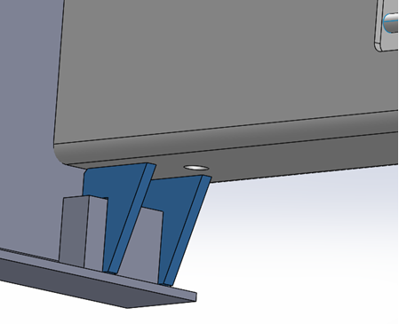

Technical drawing on locations and welding requirements are attached.

Similar to the Dorsey version there is a gusset that is to installed at the back of the slider stop, however they have moved its’ position forward to minimize the gap between the end of the block and the gusset. They have also added a second gusset that is to be installed close to the front of the slider stop. The second gusset will be pre-cut at the factory to allow it to fit over the slider stop as indicated in the picture above.

The Chassis involved in this project should be

NAPZ172001 – NAPZ172055 MFG2017 55 Chassis

To accommodate these new modifications the following repairs will be added to the system effective 5/17/21.

RepID | Component | Repair | Effective | HRS | Description
2498 | KWIK Bolster warranty | Modifications/Miscellaneous | 5/17/21 | 2.5 | Stop drill, weld, grind and Installation of KWIK bolster gusset set
2497 | KWIK Bolster Warranty | Install | 5/17/21 | 1.5 | Installation of KWIK bolster gusset set only

All parts are to be ordered directly from KWIK. Please direct all parts requests to

Nishanth Chandupatla Nishanth@kwikequip.com

When requesting parts,
- Please include a picture of the chassis from the rear indicating the defects.
- Include the unit number and “KWIK BOLSTER PARTS REQ” in the subject line.
- Copy Corp M&R on your request and all related correspondence

There will also be a new part added to the system for the new second gusset to be installed. This will be KWIKBGUSN2.

Before and after picture requirements are not changed.

Please direct any questions on these repairs to the CCM Technical Services Dept.

